Notes 2/9
- Rachel knows a lot
- Dr. Schwartz explaining it is really good to talk through our assumptions before presenting any results, always double check on numbers we’re using
- Then, start showing results
- He says put in any data (e.g., Everett Airport) and use the tools to figure things out for temperature info. Don’t be deterred by uncertainty.
- We can look at NOAA data (or from any meteorological site)
- Efficiency of boilers don’t change. Buildings walls don’t change either. Can do this for all the propane data and then figure out what the sizes of the furnaces are and divide lines by sizes of the building.
- Take data and put it vs. temperature.
- Temp. kept inside at 70 (but typically 72 degrees).
- MediaStat.com - Mick using this to try to find temperature data
- The more efficient, line goes down, less efficient line goes up:
- 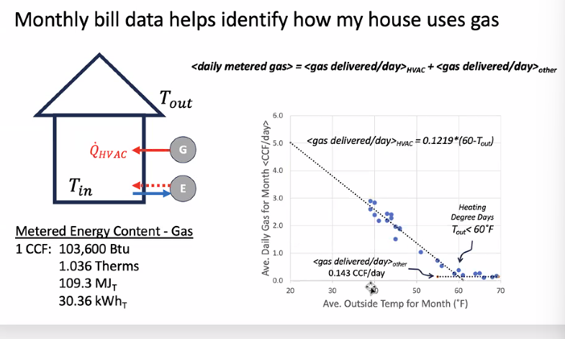
- Going to have to estimate the non-HVAC load. Need to study as a team, visualize all the data we have.
- PSE flex program - research this, how they’re trying to get people to use energy. Seattle City Light doing time of use, potentially also PSE.
  - Planned change in rates (use rates) - buying electricity at times when others don’t use it makes it cheaper, buying at peak times is expensive. Based on time of day. Economics drives adoption of batteries - dictates $/kWh
  - PSE needs economic signals to make people discharge battery when valuable to utility (so they don’t have to buy expensive energy). They can do this with a flex program - they send a signal out and people respond to the signal, getting paid for responding.
  - Much more targeted way for utility to save money.
  - Drives the economics of our design. We need to derive a rate structure based on this.
- Sounds like Rachel doesn’t think this will be a resiliency building (not focused on battery-related resilience, more so on the PV savings)
  - The only thing that might drive the incentive for a battery is the flex program
- Use ReOpt to present options - can include Battery estimates
- This quarter: business as usual and building estimates to determine how to disaggregate information.
- WA state - max 100 kW net metering limit
- 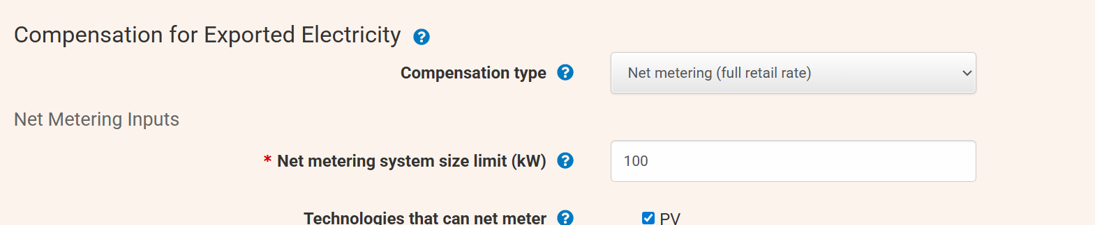
- Propane usage - haven’t disaggregated
  - E.g., divide by three if three HVACs
- Make a spec sheet for major info - units, important numbers that drive use of energy
  - Model replacement using XX COP data, etc.
- Put long-term trendline on propane data from Mick’s Python - see if there is a clear fuel escalation rate.
  - One of the biggest reasons to convert from fossil to electricity is that fossil fuels blow up budget sometimes unexpectedly, goes up and down by global markets. Harder to predict than electricity prices.
  - Major fossil fuel users have trading agreements that allow them to buy shares, control the variability.
- Set tax to 0.01
- 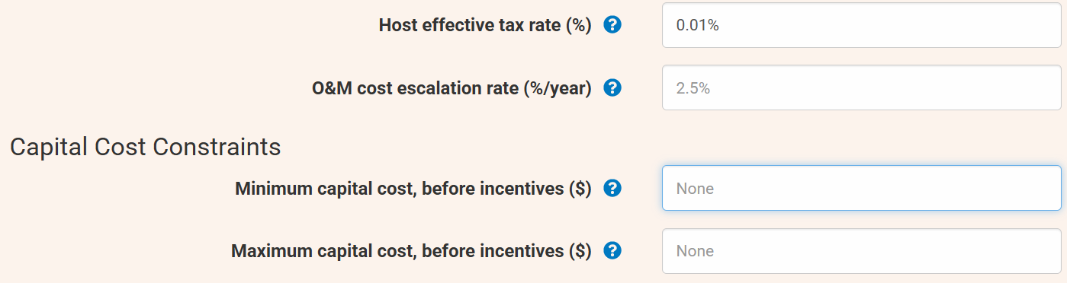
- Capital cost restraints not applicable here
- Ignore emissions/renewable energy metrics info
- 